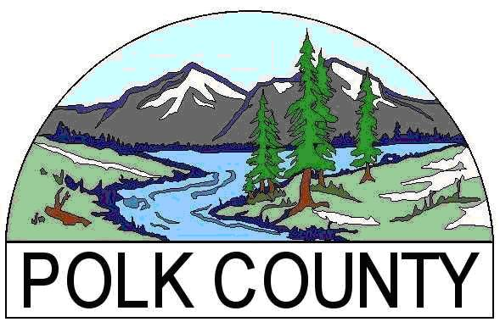
Business Development Grants
Application Form

Date:
Organization Name:
Fiscal sponsor if applicable:
Industry Type: |  |  |  |  |  | Manufacturing |  |  |  |  |  |  | Natural Resources |  |  |  |  |  |  | Tourism |  |  |  |  | Other:  ______________
 |  |  |  |  |  | Retail |  |  |  |  |  |  | Education/Workforce |  |  |  |  |  |  | Trade Sector Industries |  |  |  |  | Natural Resource-based Industries
Address
City |  |  |  |  |  |  |  |  |  | State |  |  |  |  |  |  |  |  | Zip Code
Phone |  |  |  |  |  |  |  |  |  |  |  |  |  |  |  |  |  |  | Fax
Website
Employer ID number (EIN) |  |  |  |  |  |  |  |  |  |  |  |  |  |  |  |  |  |  | Year org. established
Number of paid employees |  |  |  |  |  |  |  |  |  |  |  |  |  |  |  |  |  |  | Total FTE
Organization Director |  |  |  |  |  |  |  |  |  |  |  |  |  |  |  |  |  |  | Prefix (Mr., Ms., etc.)
First Name |  |  |  |  |  |  |  |  |  |  |  |  |  | Last Name
Title |  |  |  |  |  |  |  |  |  |  |  |  |  | E-Mail
Project Contact Person |  |  |  |  |  |  |  |  |  |  |  |  |  |  |  |  |  |  | Prefix (Mr., Ms., etc.)
Name |  |  |  |  |  |  |  |  |  |  |  |  |  | Title
Phone |  |  |  |  |  |  |  |  |  |  |  |  |  | E-Mail
Project Category  (select ONLY one) |  |  |  |  |  |  | Business Recruitment - new to Polk County |  |  |  |  |  |  |  |  |  |  |  |  |  | Business Retention – prevent the loss of jobs in Polk County
 |  |  |  |  |  |  | Business Expansion – creating new jobs through expansion |  |  |  |  |  |  |  |  |  |  |  | Project will occur in Polk County. |  |  |  |  |  |  |  | Yes  No
Project Title and Start Date
Project Description
(one sentence)
Key Project Components
(a snapshot of your project and number of jobs created)
Number of new jobs created during Jul. 1, 19 – Jun. 30 (year 1) |  |  |  |  |  |  |  |  |  |  |  |  |  |  |  |  | Total FTE of Jobs created
Number of new jobs created during Jul. 1, 19 – Jun. 30 (year 2) |  |  |  |  |  |  |  |  |  |  |  |  |  |  |  |  | Total FTE of Jobs created
Business Retention Projects Only - Number of jobs retained by the project |  |  |  |  |  |  |  |  |  |  |  |  |  |  |  |  | Number of indirect jobs created by the project (not employees of applicant)
Total Project Budget |  |  |  |  |  |  |  |  |  |  |  |  |  |  |  |  | Total Grant Request
Please list other funding sources and amounts for this project; indicate if the funding has been secured (committed) with a “Yes” or “No”.
Source |  |  |  |  |  |  |  |  | Amount |  |  | Secured |  |  |  | Source |  |  |  |  |  |  |  | Amount |  |  |  | Secured
Please list grant applications submitted in the past five years to any Polk County Economic Development Grant program. Include amounts requested and awarded.

With my signature I certify the following: (1) The above information is correct; (2) I am authorized by the organization to submit this grant application; and (3) This organization is in good standing with the IRS.
Printed Name of Authorized Agent |  | Title
Signature of Authorized Agent |  | Date

Business Development Grants
Grant Narrative

Please complete the questions below. Attach supplementary pages to narrative if additional space is needed. Relevant Letters of Support are also encouraged.

Your Organization’s Name:

Tell us about your business or organization. What are your products or services, market, workforce and financial situation? Highlight two or three key facts that best define you.

Describe the project you are requesting funding for. Provide a brief description of the project including the project location, how the project will expand or create capacity within your organization.

What activities will be funded by the grant? What is the plan for implementing the project? Provide a detailed description of the activities to be funded by the grant including timelines for starting and completing each activity. When will grant funds be needed?

How many jobs will be created or retained? How many jobs will be created within your organization? Include the position title, hours per year, pay and benefits information and number of jobs created for each position. A full-time job is defined as 1,768 or more work hours during a twelve month period. Insert more rows as needed.

Position Title | Average Pay | Benefits Included? | Hours per year | Number of positions

How many jobs will be retained? (Business Retention applicants only) How will the project result in employee retention? Include the position title, hours per year, pay and benefits information and number of jobs retained for each position. Insert more rows as needed.

Position Title | Average Pay | Benefits Included? | Hours per year | Number of positions

How many indirect jobs will be created as a result of this project? Indirect jobs are jobs created outside of your organization as a result of the project i.e. construction jobs created as a result of your building expansion, or increase in truck drivers needed by your transportation vendor as a result from an increased shipments by your organization.

How will you measure results? What will success look like? How will you measure or document project success or impact? Cite three (3) clearly defined measurements (results) you can use to demonstrate your project achieved its goals.

Describe the economic development significance of this project for the community. Will the project expand your organization’s services/products? Will the project bring sales revenue from outside of Polk County? Will the project result in an increase in the taxable assets of the organization? Will the project impact workforce development in the County? How does the project support economic development?

Who is responsible for your project? Who are the key people involved with the project? Include their names, titles, and roles. Identify the person responsible for grant reporting and compliance?

How much will the project cost? What expenses are associated with this project? What revenue sources do you currently have or do you plan to secure for this project? Include a description of the revenue and expenses included in the budget worksheet and describe how they relate to the project. Please note: Project revenues and expenses described here should correlate to project activities and match your attached project budget.

Why is grant funding needed? What other sources, if any, are you seeking for this project? If the grant award is less than the requested amount, will the project be able to move forward?

