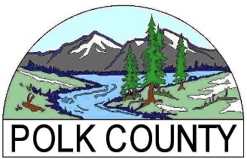
Business Development Grant
FY 2023-2024

ATTACHMENT B – ASSURANCES

Organization’s Name:

My signature below indicates that I understand that if my organization is awarded funds under this application, I will sign a Contract before funds are delivered and comply with the terms and conditions therein for the duration of the project. This Contract will include the following:
- Agree to specific measurements that can identify the effectiveness of my project.
- Provide proof of matching funds prior to release of grant funds as required by County.
- Agree to a Money-Back Guarantee on grant funds.
- Allow Polk County to disclose limited organization information (non-proprietary) on the type and amount of grant awarded by Polk County, the benefits my organization has committed to create relevant to this grant program, and the outcome of fulfilling those commitments.
- Track expenditures related to this project separately from other organizational funds, and provide reports at specified intervals agreed upon in the contract.
- Complete project reports as outlined in the contract, including a final report at the end of the project providing both anecdotal information and data on the project’s outcomes. (Final payment will not be made until a final report is accepted and reviewed by the Polk County Board of Commissioners.)
- Maintain sufficient resources on hand to cover project costs incurred between invoices. (Invoices may be submitted once each month, or as negotiated.)
- Recognize Polk County Board of Commissioner’s contribution in all press releases, news articles, marketing materials, etc. related to the program or project accomplishments.

I certify that I have the authority to sign this application on behalf of my organization.

Printed Name of Authorized Agent |  | Title
Signature of Authorized Agent |  | Date

