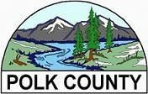

# Agenda

Local Addiction Prevention Planning Committee

|  |  |  |  |
| --- | --- | --- | --- |
| Date:  Day: | **November 3, 2021**  **Wednesday** | Location: | Board Conference Room  850 Main Street |
| Time: | **12:00 p.m. to 1:00 p.m.** |  | Dallas, OR 97338 |

1. Opening and Note of Attendance/Recognition of Visitors Jodi Merritt, LAPPC Chair
2. Fentanyl Jill Dale
3. Round Table

\*\**Next scheduled meeting – Wednesday, January 5, 2022*